Ignore files and .gitignore File

What is a .gitignore file?
# Source: AI Source: Provided by: [Data Path: Persons Table -> ID Column: 1, Name_En Column: Motasem Essam] -> From: [ChatGPT] on [2/15/2026]
A .gitignore file tells Git:
“Ignore these files or folders. Don’t track them, don’t add them to commits.”
- It’s a text file in your repository.
- It helps keep your repository clean from temporary files, build artifacts, or sensitive info.
- Git will skip anything listed in .gitignore when you do git add ..

Why use .gitignore?
# Source: AI Source: Provided by: [Data Path: Persons Table -> ID Column: 1, Name_En Column: Motasem Essam] -> From: [ChatGPT] on [2/15/2026]
- Prevent committing unnecessary files
  - Log files, temporary caches, compiled binaries
  - Example: *.log → ignore all .log files
- Protect sensitive info
  - API keys, passwords, config files
- Keep repository clean & portable
  - Avoid including OS-specific files like Thumbs.db or .DS_Store

Example .gitignore file
# Source: AI Source: Provided by: [Data Path: Persons Table -> ID Column: 1, Name_En Column: Motasem Essam] -> From: [ChatGPT] on [2/15/2026]
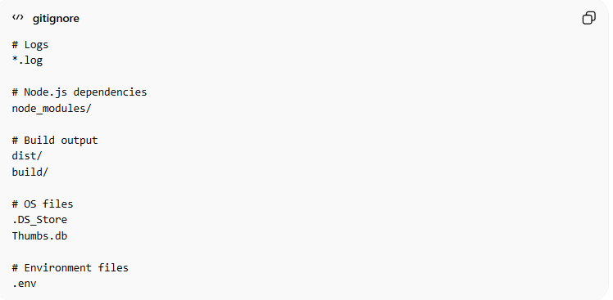
# Logs
*.log

# Node.js dependencies
node_modules/

# Build output
dist/
build/

# OS files
.DS_Store
Thumbs.db

# Environment files
.env
- With this .gitignore, Git won’t track logs, build folders, node modules, OS junk, or .env files.

💡 Tip:
# Source: AI Source: Provided by: [Data Path: Persons Table -> ID Column: 1, Name_En Column: Motasem Essam] -> From: [ChatGPT] on [2/15/2026]
- .gitignore only affects untracked files.
- If a file is already tracked by Git, adding it to .gitignore won’t stop Git from tracking it. You’d need to git rm --cached file.txt first.

